Objective

1. Study of Switch Algorithm, MAC Address Tables and configuration of Vlan

Looking at the Switch Algorithm and Switch MAC Address Tables

Step 1
Open the UsingSwitch.pkt file. Do not save the changes to the current network. Notice the similarity to the previous topology. The layer 1 hub has been replaced with a layer 2 switch (if not present, create the topology).
Click on the Simulation icon to switch to simulation mode.

Step 2 Viewing the Switch MAC Address Table

Use the Select tool to view IP address and MAC address information for the various hosts.
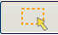 Use the Inspect tool to view the MAC Address Table of the switch.
The MAC Address Table is empty as it has not learned any Source Ethernet MAC Addresses. Notice that there is also a VLAN column in this table.

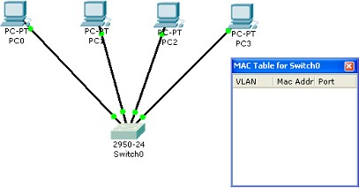

Step 3: Issuing a Ping and Viewing the MAC Address Table
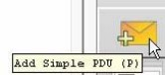
Using the Add Simple PDU perform a ping from PC0 to PC1. Choose the Add Simple PDU tool from the toolbox:

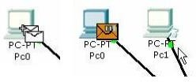
Click once on PC0, the device issuing the ping (ICMP Echo Request) and then click once on PC1 (the destination of the ICMP Echo Request).
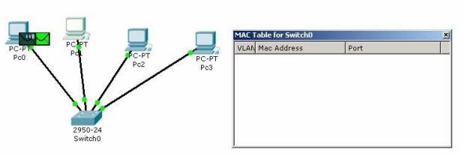
Run the simulation using the Play button.

Notice how the Switch learns the Source MAC Address of the frame:
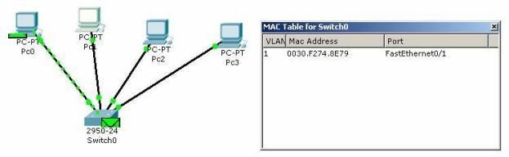

The packet is flooded out all ports because the Switch’s MAC Address Table does not contain the Destination Address of the Ethernet frame. PC2 and PC3 disregard the frame:

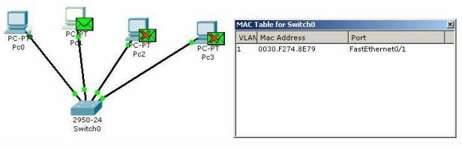

PC1 return the reply. Switch0 learns the Source MAC Address of PC1:
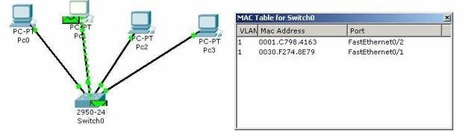
Because the Source MAC Address of PC0 was learned previously, when examining the Destination MAC Address of the frame, Switch0 filters the frame by only sending it out FastEthernet port 0/1
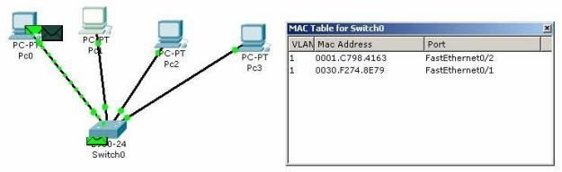
The rest of the pings, frames with IP packets containing ICMP Echo Requests from PC0 destined for PC1 and frames with IP packets containing ICMP Echo Replies from PC1 destined for PC0, are filtered by the switch an only sent out the appropriate interface (port).
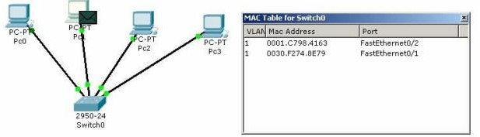

Tasks:
Build the following network in Packet Tracer:
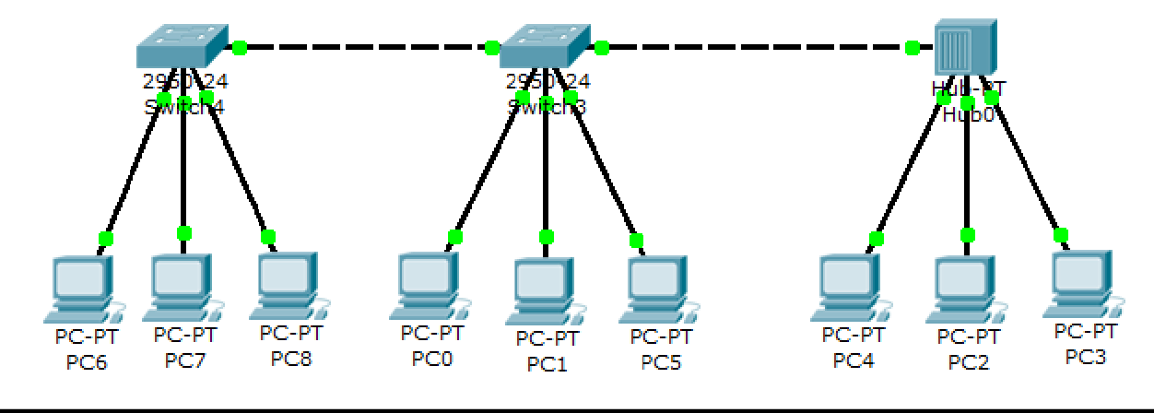
Task 1:
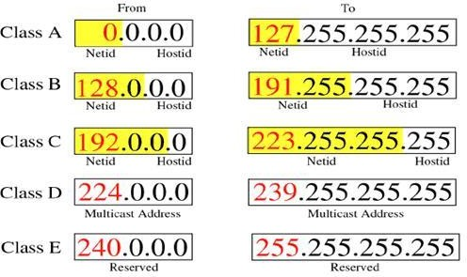
Assign first 6 PC’s with class C addresses and last three with Class B addresses. Now send packets using PDU tool from PC0 to PC3. Does the packet transmit?

Task 2:
Now assign all the PC’s with class C addresses and again send packets using PDU tool from PC0 to PC3. Does this ping this time?

Task 3:
Using PDU tool, send the packets from PC6 to PC4 and observe the transmission of switch and the hub. How they differ?

Task 4:
Again, using PDU tool, send packets to complete the MAC address tables of both the switches. Also observe how the switches update their MAC tables.

Create the following Network topolgy:

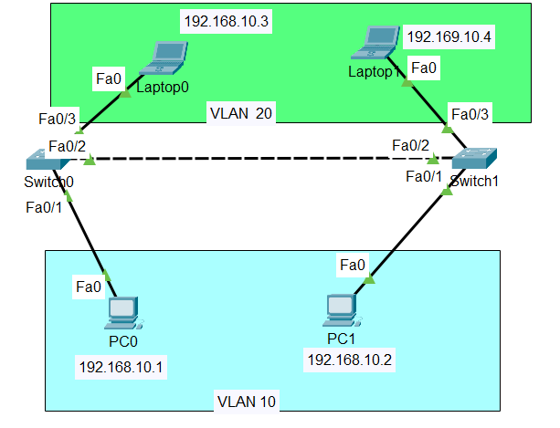

Create 2 VLANs on the switch: VLAN 10 and VLAN 20. You can give them custom names.
Switch#config terminal
Switch(config)#vlan 10
Switch(config-vlan)#name SALES
Switch(config-vlan)#vlan 20
Switch(config-vlan)#name IT
And just before you configure, have in mind that switch ports could be either access or trunk.
- An access port is assigned to a single VLAN . These ports are configured for switch ports that connect to devices with a normal network card, for example a PC in a network.
- A trunk port on the other hand is a port that can be connected to another switch or router. This port can carry traffic of multiple VLANs.
So in our case, we’ll configure switch interfaces fa 0/1 as access ports to connect to our PCs. Here, interfaces fa 0/1 assigned to VLAN 10 while interfaces fa 0/3 are assigned to VLAN 20.
Switch Interface fa0/2 will be configured as trunk port, as it will be used to carry traffic between the two VLANs via the router.
Perform the underlying steps for switch 0 and switch 1 separately:
Switch>enable
Switch#config terminal
Switch(config)#int fa0/1
Switch(config-if)#switchport mode access
Switch(config-if)#switchport access vlan 10
Switch(config-if)#int fa0/3
Switch(config-if)#switchport mode access
Switch(config-if)#switchport access vlan 10
Switch(config)#int fa 0/3
Switch(config-if)#switchport mode trunk

4 . Assign static IP addresses to the four PCs which are located in the separate VLANs. PC0 and PC1 fall in VLAN 10 while laptop0 and laptop fall in VLAN 20. At this point let’s try to test connectivity within VLANs and between VLANs
Conclusion:

